

Risk Assessment Report
Bosch Rexroth Mini Factory

The Chocolate Factory, Veghel

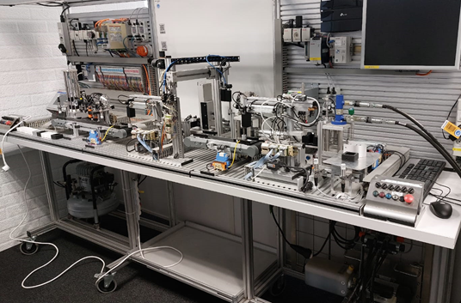
Author(s)
Anastasiia POLIMASHEVA

Revision
0000, 09-APR-2025
Project number

General
Project name | : | Bosch Rexroth Mini Factory
Reference Actemium | :
Reference Customer | :
Reference End User | :
Customer | : | The Chocolate Factory
Address | : | Verlengde Noordkade 14 5462 EC Veghel
Postal address | : | PO Box
Telephone | : | +31 6 155 252 96
Contact | : | Bart Coppes (bart.c@thechocolatefactory.nl)
End User | : | The Chocolate Factory
Address | : | Verlengde Noordkade 14 5462 EC Veghel
Postal address | : | PO Box
Telephone | : | +31 6 155 252 96
Contact | : | Bart Coppes (bart.c@thechocolatefactory.nl)
Contractor | : | PSZO BV
Address | : | Poort van Veghel 4940 5466 SB Veghel
Postal address | : | PO Box 248 5460 AE Veghel
Telephone | : | +31 88 831 89 99
Contact | : | Anastasiia POLIMASHEVA (nastia.polimasheva@actemium.com)

Approval

Actemium | Name | Function | Signature / Date
Written by | Anastasiia POLIMASHEVA
Approved by

Customer | Name | Function | Signature / Date
Approved by
Approved by
Authorized by

End User | Name | Function | Signature / Date
Approved by
Approved by
Authorized by

Distribution List

Revision | Date | To | Company
0000 | 09/04/2025

Document History

Revision | Date | Details | Author
0000 | 09/04/2025 | Risk assessment performed by intern | Anastasiia Polimasheva

Table of Contents

General 2
Approval 3
Distribution List 3
Document History 4
Table of Contents 5
Summary 6
References 7
1 Introduction 8
2 Determination of limits of machinery 9
3 Risk assessment 11
4 System Design and Safety Implementation 21
5 Full Component & Manufacturing Table 37
6 Maintenance Plan 39
7 Testing and Validation Plan 42
8 Conclusions and recommendations 43
9 Appendix A: project`s GitHub 44
10 Appendix B: proposed components 45
11 Appendix C: Maintenance Forms and reports 46

Summary
This risk assessment report evaluates the adaptation of the Bosch Rexroth Mini Factory for a public, educational exhibit at The Chocolate Factory in Veghel, Netherlands. Originally designed for industrial training, the Mini Factory replicates real-world automation processes using pneumatics, hydraulics, and PLC control. The transformation aims to make this system safe and engaging for children aged 8+, as well as educators and museum facilitators.
The assessment follows ISO 12100 for identifying and mitigating hazards across mechanical, electrical, software, and human interaction domains. Major risks include user exposure to moving parts, electrical contact, misuse by children, and improper maintenance. Mitigations include physical enclosures, interlocks, rewiring, improved cable management, and software safeguards. Safety zones were implemented using custom sliding doors and transparent panels, with detailed attention to stopping distances, component materials, and ergonomic access. This report incorporates proposed testing plan for safety validation.
The report proposes a layered safety approach including mechanical end-stops, E-stops, RCDs, access control levels, and sensor-monitored covers. Future upgrades such as light curtains and laser scanners are considered but not currently implemented due to budget constraints. The documentation outlines physical design, electrical redesign, and staff training plans to ensure both educational effectiveness and safety compliance.

References

Related Documents
- PoA-Bosch Rexroth Factory-0000
- URS-Bosch Rexroth Mini Factory-0000
- REP-Mini Factory-0000

Applied Standards
- [ISO 12100] Safety of machinery – General principles for design – Risk assessment and risk reduction, ISO, 2010.
- [ISO 13849-1] Safety of machinery – Safety-related parts of control systems – Part 1: General principles for design, ISO, 2015.
- [ISO 14120] Safety of machinery – Guards – General requirements for the design and construction of fixed and movable guards, ISO, 2015.
- [ISO 13857] Safety of machinery – Safety distances to prevent hazard zones being reached by upper and lower limbs, ISO, 2019.
- [ISO 14119] Safety of machinery – Interlocking devices associated with guards – Principles for design and selection, ISO, 2013.
- [ISO 13855] Safety of machinery – Positioning of safeguards with respect to the approach speeds of parts of the human body, ISO, 2010.
- [IEC 61512-1 / ISA-88.01] Batch Control – Part 1: Models and Terminology, IEC, 1997.
- [ISO 13851] Safety of machinery – Two-hand control devices – Functional aspects and design principles, ISO, 2019.
- [IEC 60204-1] Safety of machinery – Electrical equipment of machines – Part 1: General requirements, IEC, 2016.

Literature
- [AR01] Wickens, C. D., Lee, J. D., Liu, Y., & Becker, S. E. G. An Introduction to Human Factors Engineering, Pearson, Boston, 2020.
- [AR02] Salvendy, G. Handbook of Human Factors and Ergonomics, Wiley, Hoboken, 2012.
- [AR03] Kmenta, S., & Ishii, K. Scenario-Based FMEA: A Life Cycle Cost Perspective, Proceedings of the ASME Design Engineering Technical Conference, 2000.

Introduction

As automation technology becomes increasingly embedded in education and public engagement, ensuring safety without compromising interactivity is a critical design challenge. Actemium, in collaboration with The Chocolate Factory in Veghel, Netherlands, is addressing this challenge through the transformation of the Bosch Rexroth Mini Factory into a hands-on learning environment. Originally designed for industrial training, the Mini Factory combines pneumatics, hydraulics, sensor systems, and PLC control to replicate real-world automation processes.

This project aims to adapt the system for an educational exhibition targeted primarily at children aged 8 and above, alongside secondary users such as educators, museum facilitators, and technical staff. The result must be an experience that is not only informative and engaging but also demonstrably safe and compliant with international safety standards.

Risk assessment is therefore an essential foundation for the system's redesign. This report identifies potential hazards, evaluates risks based on severity, occurrence, and detectability, and proposes corresponding mitigation strategies. The assessment process aligns with ISO 12100 guidelines for risk assessment and risk reduction, as well as related standards such as ISO 13849-1, ISO 14120, and ISO 13857, which define requirements for control system safety, guarding, and safety distances, respectively.

Analysis begins with defining machinery limitations, indicating what is the use case and audience of the project. Then followed with Risk Assessment section, analysis drives deeper into what are the risks and what mitigation actions can help. Action list is created based on mitigation actions and includes design choices. And at the end is the section about implementation of safety measures and their validation.

Determination of limits of machinery
In accordance with ISO 12100, the first step in the risk assessment process is to define the limits of the machinery. This step ensures that the system is evaluated under realistic operating conditions and foreseeable misuse scenarios—especially important for this project, where the primary users are children.
By clearly outlining the operational, spatial, temporal, and user-specific boundaries, this section establishes the context in which all safety risks must be assessed. These limits form the foundation for a systematic and standards-compliant risk assessment process presented in later sections.

Use Limits
- Intended use:
  - Educational interaction for children aged 8+
  - STEM engagement and gamified learning
  - Demonstration and leisure modes
  - Beginner and intermediate programming activities (e.g., Scratch, JavaScript)

- Reasonably foreseeable misuse:
  - Children bypassing safeguards
  - Children are not paying enough attention during operation of the machine, which leads into hits, scratches, unintended objects inside the machinery
  - Pressing or interacting with controls in unintended sequences
  - Trying to access internal moving parts
  - Misuse of joysticks/levers with excessive force

Space Limits
- Physical dimensions:
  - Factory module is static, likely installed in a fixed exhibit space
  - Controls (buttons, levers, joysticks) are within reach for children (~1–1.5m height range)
  - For now placed on a moving table
- Access zones:
  - Front interface for users
  - Maintenance/back side for staff
- Hazard zones:
  - Moving parts inside the Mini Factory
  - Electrical components and connectors
  - Back side
  - Compressor zones
  - Power plugs

Time Limits
- Duration of use:
  - Short bursts of interaction (5–15 minutes per session)
  - Repeated daily use by multiple groups of visitors
  - Schools educational activities (45-60 mins)
- Maintenance intervals:
  - Weekly inspection/checks
  - Daily visual checks by facilitators
  - Half a year full maintenance

Other Limits
- User characteristics:
  - Primary users: children (8+), museum visitors, educators
  - Secondary users: technicians, facilitators, Actemium staff
  - Must accommodate various cognitive and physical abilities
- Environmental conditions:
  - Indoors (museum setting)
  - Normal room temperature and lighting
  - Moderate noise environment
- Energy sources:
  - General power line
- Connectivity:
  - PLC control with internet access and direct ethernet interface

Risk assessment
With the system limits clearly defined, a structured risk assessment is carried out in accordance with ISO 12100. The purpose of this step is to identify all reasonably foreseeable hazards and evaluate their severity, likelihood, and detectability—especially in the context of interaction by children and the public. Based on these assessment mitigation actions are proposed in section 3.2.

Risk assessment
After all the hazards are identified, for each of them, the following are specified:
- Hazard Description: Nature and source of the risk
- Affected Components: Relevant system elements (mechanical, electrical, etc.)
- Severity (S): The impact level of the hazard (scale 1–10)
- Occurrence (O): Likelihood of the hazard occurring (scale 1–10)
- Detectability (D): Likelihood that the hazard will be detected before harm (scale 1–10)
- Risk Priority Number (RPN): Product of S × O × D
- Proposed Mitigation Measures: Technical or procedural actions to reduce the risk
Hazards with an RPN above 100 are considered high-risk and require immediate action or design intervention. Medium-risk hazards (RPN 50–100) should be mitigated where feasible. Low-risk items (RPN < 50) may be monitored or addressed via procedural controls.

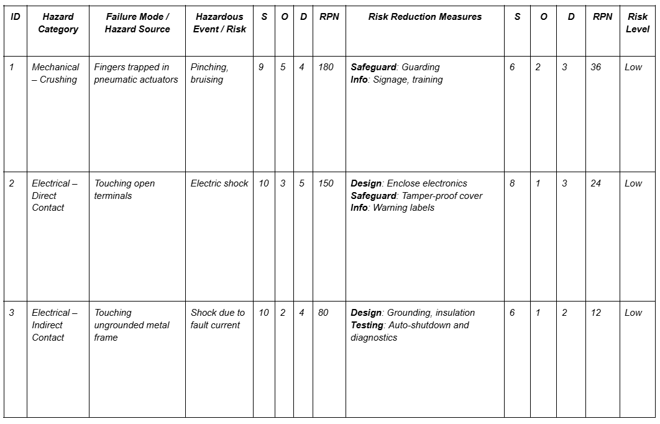
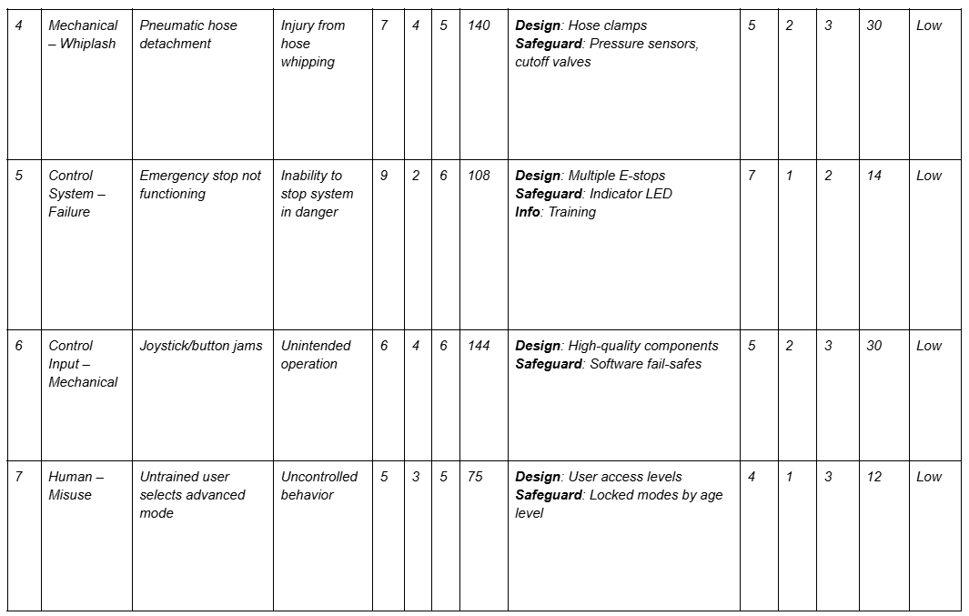
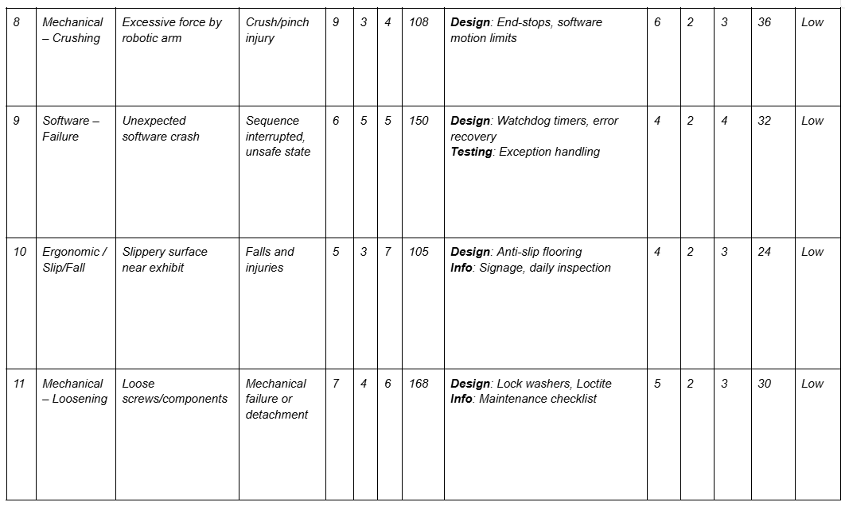
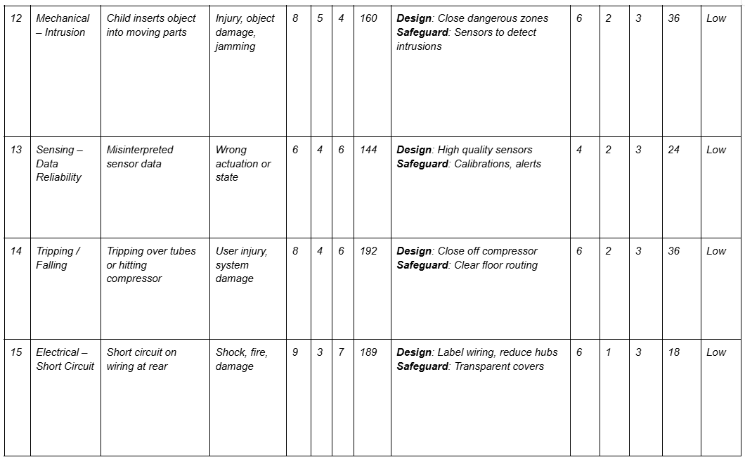

Actions Required Based on Risk Assessment
Following the structured risk identification process, a series of targeted actions must be taken to reduce identified risks to acceptable levels. These measures are justified using the hierarchy of risk reduction measures from ISO 12100, which prioritizes:
- Inherently safe design measures
- Technical protective measures (safeguards)
- Information for use (signage, training)

1. Mechanical Hazards
These hazards—such as crushing, whiplash, or component loosening—received some of the highest RPN scores (e.g., ID 1: RPN 180, ID 4: RPN 140, ID 11: RPN 168), and therefore require priority mitigation:
- End-Stops & Software Motion Limits
→ Why: Prevent overextension of robotic arms (ID 8 – RPN 108).
→ How: Physically or digitally restrict movement ranges using servo parameters and PLC conditions.
- Fixed/Sensor-Monitored Transparent Covers
→ Why: Prevent user intrusion into robotic/mechanical zones (ID 12 – RPN 160).
→ How: Use ISO 14120-compliant guards with clear polycarbonate panels and interlock sensors.
- Hose Clamps & Pressure Sensors
→ Why: Prevent hose whipping in case of pneumatic detachment (ID 4 – RPN 140).
→ How: Mechanical reinforcement + real-time pressure monitoring with auto cutoffs.
- Lock Washers & Loctite
→ Why: Address loosening of fasteners (ID 11 – RPN 168).
→ How: Standard vibration-resilient mechanical fixation methods.

2. Electrical Hazards
Electric shock and short circuit risks (ID 2 – RPN 150, ID 15 – RPN 189) are high-severity and must be addressed through protective hardware:
- Tamper-Proof Transparent Covers
→ Why: Prevent access to terminals (ID 2 – RPN 150).
→ How: Enclose electronics using ISO 14120-compliant lockable covers.
- Rewire & Remove Legacy Components
→ Why: Reduce cable clutter, avoid short circuit risks (ID 15 – RPN 189).
→ How: Centralized wiring, cable routing, removal of unused hardware.
- Grounding and RCDs
→ Why: Prevent indirect contact shock (ID 3 – RPN 80).
→ How: Earth all conductive enclosures and install residual current protection.
- Cable Management & Labelling
→ Why: Minimize fire risk and maintenance errors (ID 15 – RPN 189).
→ How: Structured wire ducting, tags, and color-coded connectors.
- Emergency Stops (E-Stops)
→ Why: Enable immediate hazard neutralization (ID 5 – RPN 108).
→ How: Install mushroom-type buttons with a safety relay (PL=d per ISO 13849-1).

3. Control System & Software Risks
Software errors, unexpected inputs, and unsafe access modes (IDs 6, 7, 9) can trigger unsafe behavior (RPNs: 144, 75, 150).
- User Access Levels (Role-Based UI)
→ Why: Prevent misuse of advanced control modes by children (ID 7 – RPN 75).
→ How: Lock advanced features behind staff login or age gates.
- Watchdog Timers & Exception Handling
→ Why: Detect and handle software crashes (ID 9 – RPN 150).
→ How: Built-in recovery and safe-state fallback logic in PLC/HMI.
- Redundant E-Stop Logic & Indicators
→ Why: Confirm E-stop reliability (ID 5 – RPN 108).
→ How: Dual-channel wiring and visual feedback (LEDs).
- High-Quality Input Devices
→ Why: Reduce jamming/false triggers from cheap buttons or joysticks (ID 6 – RPN 144).
→ How: Replace with industrial-rated components tested under vibration/load.

4. Human Interaction & Misuse
These hazards include slips, improper handling, and lack of instruction (IDs 10, 12, 14).
- Clear Signage & Instructions
→ Why: Compensate for user unfamiliarity (supporting most risks rated “Could occur” like ID 10).
→ How: Pictogram-based signage at interaction points.
- Safety Zones & Physical Dividers
→ Why: Physically isolate users per group (ID 12 – RPN 160).
→ How: Transparent screens or interlocked doors per safety zone.
- Daily & Monthly Safety Inspections
→ Why: Maintain ongoing system integrity (ID 11 – RPN 168).
→ How: Logbook entries for checks on loose parts, controls, and shields.
- Anti-Slip Flooring & Cable Management
→ Why: Reduce fall/trip risk (ID 10 – RPN 105, ID 14 – RPN 192).
→ How: Add rubber mats, shield floor wires, clear footpaths.

5. Thermal / Environmental Hazards
Issues like compressor overheating or limited ventilation (ID 14) are manageable but relevant for public installations.
- Ensure Component Ventilation
→ Why: Avoid overheating damage (ID 14 – RPN 192).
→ How: Allow airflow paths and monitor temperature if feasible.
- 3D Printed Covers for Components
→ Why: Cover exposed yet visible parts (ID 15 – RPN 189).
→ How: Transparent, snap-fit covers designed for inspection without risk.

6. Installation / Maintenance Measures
These procedures are crucial for long-term compliance and traceability:
- Maintenance Checklist & Log
→ Why: Ensure consistent checks post-implementation.
→ How: Follow ISO 12100 Annex B sample checklist and adapt it to the installation.
- Covers for Compressor & Pump
→ Why: Prevent injury from tampering (ID 14).
→ How: Combination of wood, acrylic panels, and lockable enclosures.
- Safety Zone & E-Stop Documentation
→ Why: Ensure museum staff know what’s what.
→ How: Diagrams and SOPs stored on-site and in the manual.
- Staff Training Program
→ Why: Compensate for what design can't cover (last line of defense).
→ How: Hands-on training + quick-reference guides.

Table 3.2.1 Risk–Action Traceability Matrix
Risk ID | Hazard Summary | Selected Mitigation Action | Alternative Design Options (if any)
1 | Pinching in pneumatic actuators | Install physical end-stops; use transparent guarding | Guarding type (fixed vs interlocked), end-stop software vs mechanical
2 | Touching open terminals | Enclose electronics with tamper-proof covers | Various enclosure materials and lock types
3 | Touching ungrounded frame | Install grounding and RCDs | Type of RCD or PLC-integrated solution
4 | Pneumatic hose detachment | Use hose clamps and pressure sensors | Clamp types or use of braided hose
5 | E-stop system fails | Install redundant E-stop logic with feedback | Hardwired relay vs safety PLC
6 | Joystick/button jam | Replace with industrial-grade components | Capacitive touch vs mechanical buttons
7 | Untrained user uses advanced mode | User access levels and lockout in UI | Key switch vs software lock
8 | Excessive force from robotic arm | Use motion limits and end-stops | Mechanical limit vs software-controlled torque limit
9 | Software crash | Watchdog timers and exception handling | Built-in OS watchdog vs application-based recovery
10 | Slippery surface | Anti-slip flooring and warning signs | Rubber mats vs rough surface finish
11 | Loose components | Use Loctite and maintenance checklist | Lock washers, adhesive tape, or 3D printed covers
12 | Child inserts object into moving parts | Fixed/sensor-monitored covers | Fixed transparent vs interlocked doors
13 | Misinterpreted sensor data | Use high-quality sensors, calibrations and alerts | Sensor redundancy vs software validation
14 | Tripping over tubes or hitting compressor | Clear tubing path and compressor enclosure | Wall-mounting tubes vs routed floor guides
15 | Short circuit due to wiring | Rewire, label, and enclose components | Labeling standards or modular wiring panels
Table 3.2.1 is a traceability matrix that links each identified hazard from the FMEA (Appendix F) to the corresponding mitigation actions described in Chapter 4.3. Each action has been chosen based on its effectiveness in reducing the associated Risk Priority Number (RPN), in accordance with ISO 12100 hierarchy of risk reduction measures.
Where applicable, alternative design options are provided to support future implementation flexibility. These alternatives may be considered during procurement, budget planning, or later development phases.

Target Performance Levels for Safety Functions
To ensure the reliability of safety-related parts of the control system (SRP/CS), this project aligns with the ISO 13849-1 standard by defining Performance Levels (PL) for each core safety function. A Performance Level indicates the ability of a safety function to achieve its intended risk reduction with a quantifiable probability of dangerous failure per hour (PFHd). The levels range from PL a (lowest) to PL e (highest), depending on the severity of potential injury, frequency of exposure, and possibility of avoiding the hazard.
Table 3.3.1 summarizes the target PLs for all safety functions based on the risk priority numbers (RPN) identified in the FMEA and the system use case (public exhibit for children aged 8+). These levels provide a guideline for selecting appropriate hardware (e.g. relays, sensors, interlocks), wiring redundancy, and diagnostic coverage.
Table 3.3.1 Target Performance Levels for Safety Functions
Safety Function | Related Risk ID(s) | Description of Hazard or Failure Mode | Target Performance Level (PL) | Justification
Interlocked Safety Doors | ID 12, ID 8 | Prevent intrusion into moving zones | PL d | High risk of child access to robotic arms, frequent exposure
Emergency Stop System | ID 5 | Enable quick deactivation in all zones | PL d | Multiple zones with active motion; E-stop required per zone
Motion Limit Software | ID 8, ID 9 | Prevent overtravel of actuators | PL c | Software safeguard complementing physical stops
Compressor & Pump Isolation | ID 3, ID 14 | Risk of electrical shock or mechanical impact | PL b | Less frequent access, lower exposure risk
Transparent Fixed Covers | ID 1, ID 4 | Prevent access to pinch points and pneumatics | PL c | Passive protection, complemented by design safeguards
Rear Electrical Panel Protection | ID 2, ID 15 | Prevent contact with live terminals or short circuits | PL d | High-severity risks, must be reliably enclosed and tamper-resistant
Admin Access Control in Software | ID 7 | Prevent unauthorized access to advanced system features | PL c | Moderate risk, mitigated through software login and UI control
Safety hardware such as non-contact interlocks, dual-channel safety relays, and coded E-stop circuits will be selected to meet these PL targets, in accordance with manufacturers’ SIL/PL ratings and validated during system integration.

System Design and Safety Implementation
With the risk mitigation strategies defined, the focus shifts to integrating them into the physical and functional design of the Mini Factory. This section describes the concrete safety features implemented into the system—ranging from hardware modifications and protective housing to control logic and user interface safeguards. The goal is to create a system that not only meets technical safety standards but also promotes intuitive and secure interaction for children, educators, and maintenance personnel. Design decisions are documented in alignment with the previously defined system requirements and risk controls.

Protective Zoning and Barriers
Goal: To physically separate users from dangerous moving components and prevent accidental access to internal mechanisms.
Related Risks: ID 1 (pinching), ID 8 (overextension), ID 12 (object intrusion)
As the installation is designed to serve three groups of children simultaneously, the system was divided into three physically distinct safety zones. This decision was made in consultation with Actemium and The Chocolate Factory stakeholders, who agreed that parallel interaction supports both pedagogical goals and crowd management in the museum setting. Each group works independently in one zone, guided by a dedicated screen interface, allowing multiple teams to explore the system at once without interfering with one another. This design also enables targeted safety monitoring and emergency stop functionality per zone.
To secure these zones, several physical separation strategies were evaluated based on safety requirements (ISO 12100, ISO 13849-1, ISO 13857, and ISO 14119):
Options Considered:
- Fixed Transparent Polycarbonate Screens
  - Pros: Low cost, simple to install, excellent visibility, no mechanical maintenance
  - Cons: Inhibits access for staff or interactive learning modules
  - Compliance: ISO 13857 (safety distances), polycarbonate ≥6 mm
- Interlocked Sliding Doors with Type 4 Guard-Locking Switches
  - Pros: Safe access when needed, enables more interactive zones
  - Cons: More expensive than fixed screens, requires maintenance, alignment
  - Compliance: ISO 14119 (interlocking), ISO 13849-1 (PL=d/e safety logic)
- Light Curtains or Area Laser Scanners
  - Pros: No physical barrier, adaptable safety zone
  - Cons: Expensive, sensitive to museum lighting and user clutter
  - Reason Excluded: Cost-prohibitive for this budget-restricted phase; physical installation would expand required footprint of exhibit
- Two-Hand Operation Systems (ISO 13851)
  - Pros: Prevents single-person activation of hazardous functions
  - Cons: Not suitable for multi-user, exploratory educational settings
  - Reason Excluded: Restrictive and unintuitive for children; only applicable to specific machine operations like press activation
Chosen Approach:
A combination of fixed safety screens and interlocked doors was selected as the most effective and feasible solution.
- Fixed screens separate user zones and enclose components that do not require regular access.
- Interlocked sliding doors were chosen because they allow safe access to interactive components without increasing the footprint of the installation—a critical factor in the museum's limited floor space. Unlike outward-opening doors or hinged barriers, upward-sliding doors conserve space and are more intuitive for children.
Each sliding door was custom designed to follow a curved rail system that supports a vertical lifting mechanism. This choice allows the door to follow the natural arc of the user's motion, offering both ergonomic benefits and mechanical simplicity. The bottom door panel is intentionally larger to provide better visibility into the exhibit when the system is in a closed state. A top view of the safety zone layout is provided in Figure 4.1.1. 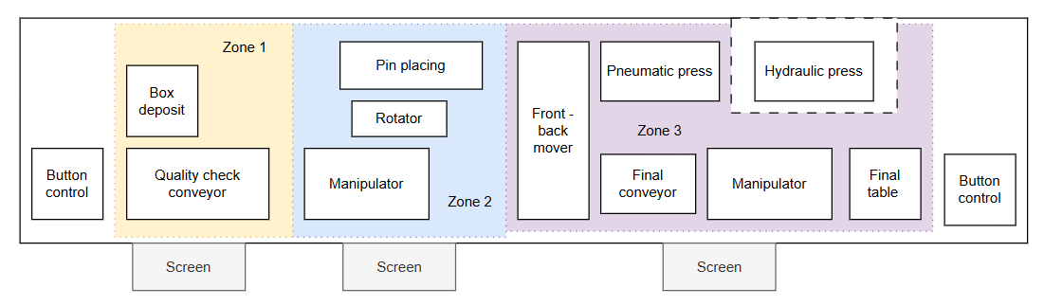
Figure 4.1.1 Safety zones division relative to the components` layout

Safety Zone Implementation – Functional Design
To fulfill the safety separation strategy practically and affordably, custom-built upward-sliding doors were implemented in each zone. These doors were preferred because they maximize space efficiency, simplify mechanical design, and minimize the risk of unintended opening. The full door assembly is shown in Figure 4.2.1.
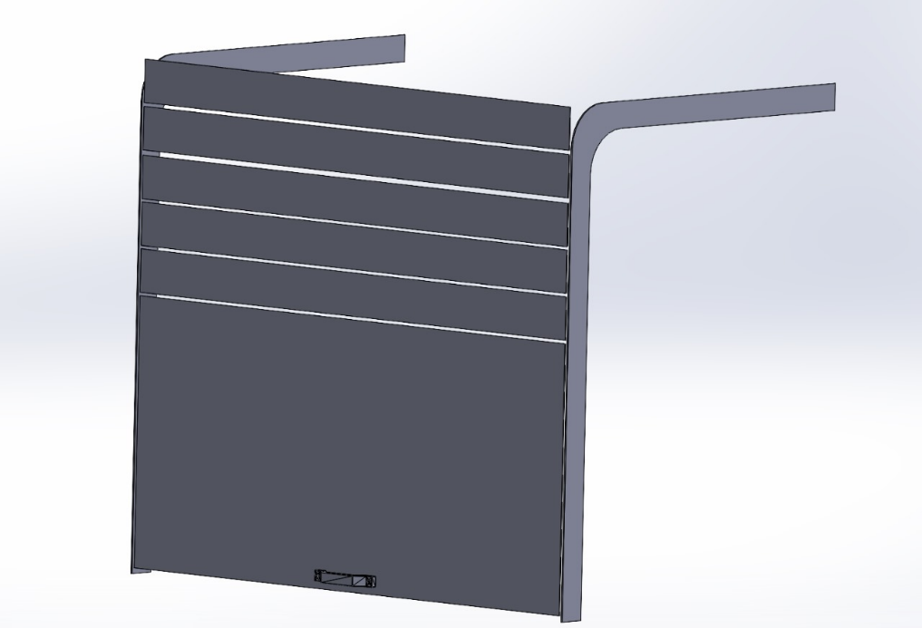
Figure 4.2.1 Safety door design
- Curtain railings are adhered to vertical aluminum profiles of the exhibit.
- Transparent acrylic door segments (cut from 3 mm plastic) are manually perforated and affixed to the rails.
- Each door comprises a large bottom segment (for visibility) and several smaller curved panels that follow the track.
- Segments are connected using 3D-printed hinges (Figure 4.2.2), chosen for their low production cost and ease of replacement. Hinges are attached with either screws or rivets, depending on the load and positioning. The top segment includes a manual handle for lifting.
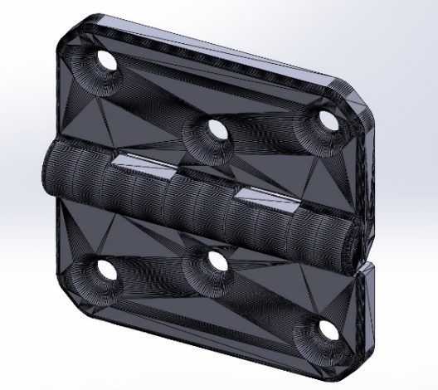
Figure 4.2.2 Hinges Connecting Door Segments
All CAD models and STL files are available in the project’s GitHub repository (Appendix B).
To ensure safe operation, non-contact coded safety switches were selected for integration into each door. These switches are compact, tamper-resistant, and comply with ISO 14119. A recommended model is the Pilz PSENcode or Schmersal RSS16, both small enough to fit within the rail structure and available through Dutch suppliers (e.g., Elobau, Conrad, or RS Components NL). Difference between non-contact safety sensors and non-contact safety switches is described in Table 4.2.1.
Table 4.2.1 Non-contact safety sensors vs. switches
Feature | Non-Contact Safety Sensors | Non-Contact Safety Switches
Functionality | Detects presence without contact | Locks/unlocks access mechanisms
PLC Compatibility | Digital I/O compatible | Integrates with safety PLCs/relays
Compliance | Some meet ISO 13849-1, SIL 3 | Compliant with ISO 14119, SIL 3, PLe
Installation | Easier, less alignment needed | More precise, higher tamper resistance
Cost | €30–150 | €50–200
Selected option: Non-contact safety switch Schmersal RSS16 (IP67, coded actuator, PL e), compact and tamper-proof, available for ~€90/unit.

Fixed Screens and Horizontal Dividers
Goal: To define and reinforce passive safety boundaries between user areas and hazardous machine components where access is not required.
Related Risks: ID 12 (object intrusion), ID 1 (pinching)
In addition to sliding doors, fixed transparent screens were implemented to establish non-interactive boundaries between exhibit zones. These screens are not merely vertical sheets but are structurally integrated into the Mini Factory’s aluminum frame.
Each screen is designed to slide into predefined horizontal slots that already exist in the aluminum beam network above the installation. However, since these slots do not divide the exhibit equally, some screens required curvature or segmentation to match the irregular layout and maintain consistent barrier coverage across zones.
The material used is impact-resistant polycarbonate with a thickness of ≥6 mm, which meets the minimum requirements of ISO 13857 for physical guarding. This material ensures both transparency and durability in a high-traffic, child-focused environment.
Mounting System:
- Screens are manually cut and shaped to follow the contour of the frame.
- Fitted into top beam slots with minimal tolerance to ensure stability.
- 3D-printed guides are used to attach vertical plexiglass panels for side enclosures.
Figures 4.3.1 and 4.3.2 illustrate the design and spatial relationship of these panels within the exhibit. For ease of assembly and alignment, each screen and bracket are labeled and pre-drilled based on CAD files available in Appendix B.
A vertical panel enclosing the electrical components is also part of the rear structure. This panel includes a cut-out slot at the top that allows it to be removed easily for maintenance. It slides into position along 3D-printed rail guides that are glued to adjacent dividers—an intuitive and tool-free solution ideal for quick staff access.

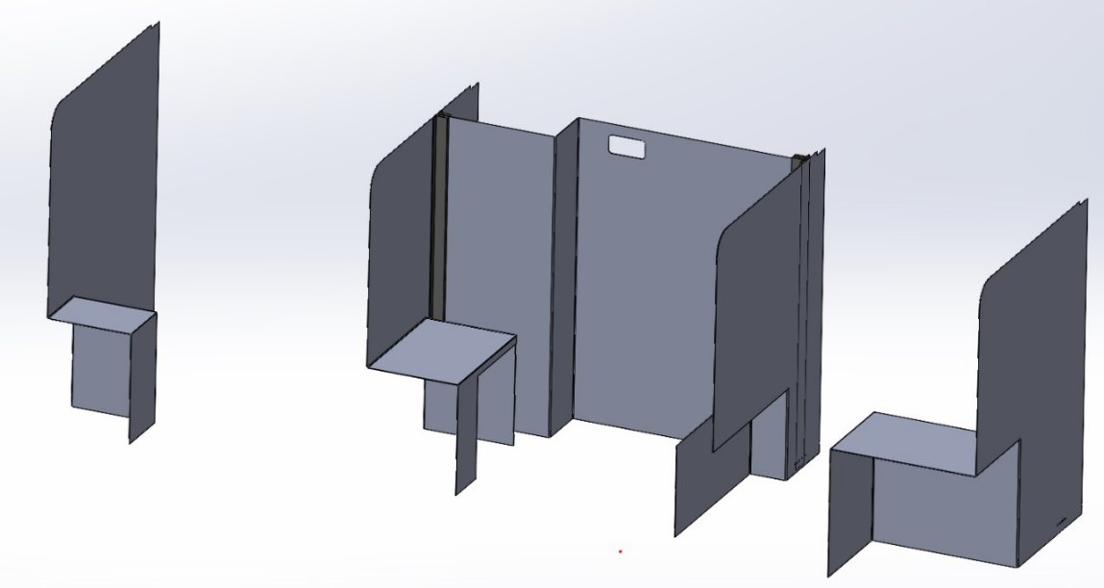
Figure 4.3.1 Main exposition dividers and electrical box design
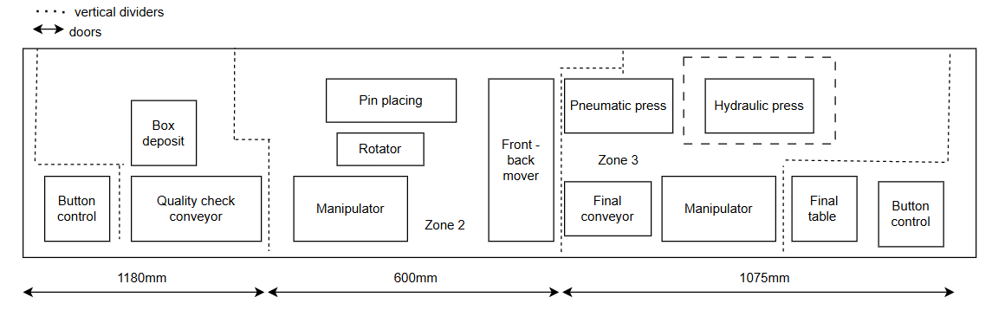
Figure 4.3.2 Schematics of zone dividers relatively to exposition`s components

Side Panel Covers for Electrical Box
Goal: To prevent contact with exposed electrical terminals and maintain safe enclosure of critical electronics while supporting educational visibility.
Related Risks: ID 2 (touching open terminals), ID 12 (object intrusion), ID 3 (ungrounded frame)
To complete the enclosure around critical electrical components, plexiglass sheets were installed on the left and right sides of the main electrical box. These panels enhance both safety and aesthetics, aligning with child-friendly design principles agreed upon by the project stakeholders.
Each side panel is inserted into custom mounting slots using 3D-printed adapters, ensuring secure attachment without the need for complex mechanical fixtures. The panels are made of 2 mm thick plexiglass, selected for its transparency and lightness. This allows for easy inspection of internal components while keeping fingers or tools from unintentionally contacting live elements.
To create a more engaging visual environment, decorative acrylic overlays were added to the external face of the panels. These overlays also serve a secondary function by encouraging visual recognition of different zones and components by young users.
All CAD files and adapter models are accessible via the project GitHub (Appendix B).
This side cover system complements the centrally placed vertical back panel of the electrical box, which is intended to provide full transparency of wiring and control systems to engage children with the technical aspect of the exhibit. It is installed directly into the middle section of the rear wall and functions as an educational display as well as a safety barrier. Figures 4.4.1, 4.4.2 and 4.4.3 show design of side covers with used adapters.
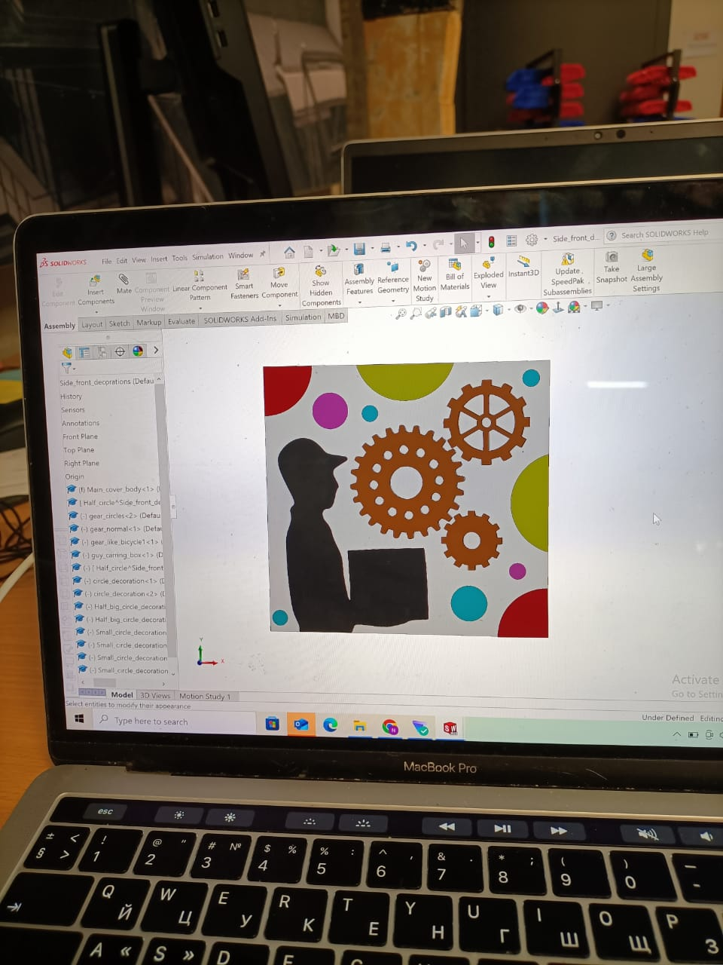
Figure 4.4.1 Right side plexiglass sheet

Figure 4.4.2 Left side plexiglass sheet
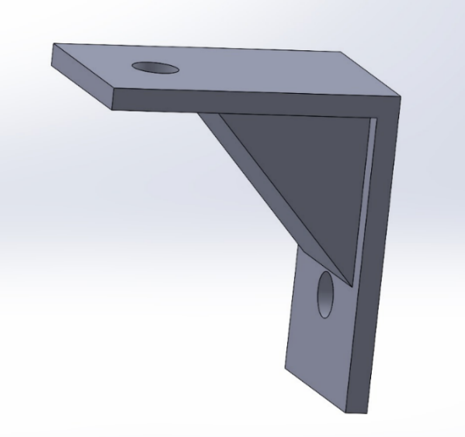
Figure 4.4.3 Side Sheet Mounting Adapter

Pneumatics Compressor and Hydraulic Pump Enclosure
Goal: To isolate high-risk components such as the compressor and hydraulic pump, reducing risk of electrical shock, accidental contact, or tampering.
Related Risks: ID 3 (ungrounded frame), ID 14 (tripping over tubes or hitting compressor), ID 1 (pinching), ID 4 (pneumatic hose detachment)
To ensure safety, minimize unauthorized interaction, and maintain visual access for educational purposes, the pneumatic compressor and hydraulic pump—both critical yet potentially hazardous components—are enclosed in a custom-built protective housing. This enclosure is particularly important due to the high pressure, electrical connections, and mechanical movements associated with these systems.
Alternative Designs Considered:
Before selecting the final approach, several enclosure concepts were evaluated:
Full-Metal Cabinet (e.g., sheet metal or industrial enclosure box)
- Pros: Extremely durable, tamper-proof
- Cons: Fully blocks visibility, reduces educational transparency, expensive to customize for irregular layouts
- Reason excluded: Contrary to educational goals and museum visibility needs
Commercial Polycarbonate Enclosure with Locking Frame
- Pros: Off-the-shelf solution, available with certifications
- Cons: Rigid sizing constraints, difficult to fit within exhibit footprint, significantly higher cost
- Reason excluded: Cost-prohibitive and not adaptable to current modular structure
Flexible Curtain Shielding or Mesh Netting
- Pros: Easy access, breathable, lightweight
- Cons: Poor physical protection, non-compliant with ISO guarding standards
- Reason excluded: Offers insufficient protection from mechanical and electrical hazards
Final Design and Rationale:
The final enclosure is a modular structure built using 6 mm thick transparent plexiglass, reinforced with wooden and aluminum elements for structural support. This solution balances cost-efficiency, aesthetic transparency, and safety compliance (aligned with ISO 12100 and ISO 14120 for protective guarding). It also integrates seamlessly into the exhibit layout without consuming additional floor space.
Design Features:
- Transparent Front, Back, Bottom and Side Panels: Enable real-time observation and educational demonstration.
- Rear Access Panel: Hinged and equipped with a padlock latch to restrict unauthorized access while allowing technician maintenance.
- Wooden Base Panel: Provides rigid support and physical separation from the floor.
- Custom 3D-Printed Corner Brackets: Secure the panels into standard 30x30 mm aluminum profiles. Chosen for ease of replacement, modularity, and reduced part costs.
- Assembly Labels and Pre-Drilled Holes: Facilitate fast and accurate installation with minimal tooling required.
- Cable Routing Slot: Integrated in the upper-right of the rear panel to allow safe entry of pneumatic and electrical lines without compromising enclosure integrity.
This configuration provides a robust barrier while still fulfilling the project's educational mission—showcasing internal components in a safe and understandable way. Furthermore, all component models and print files are documented in the project’s [GitHub repository] (Appendix B) to support replication and upgradeability in future deployments.
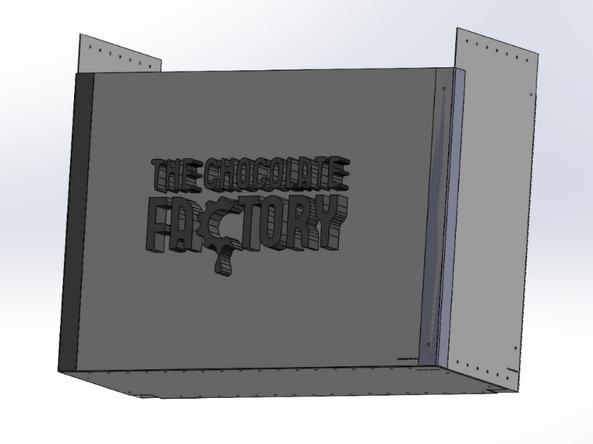
Figure 4.5.1 Enclosure design
The enclosure is composed of two side panels (Figure 4.5.1), one front panel, and back and bottom sections. Recommended material is 6 mm thick plexiglass. All parts feature assembly labels and pre-drilled holes. Connections are made using 25x15 mm hammer nuts (Moerhammers) and M6 screws. Aesthetics are enhanced by 3D-printed components forming the logo and black cover elements (Figure 4.5.2), all glued to the frame.
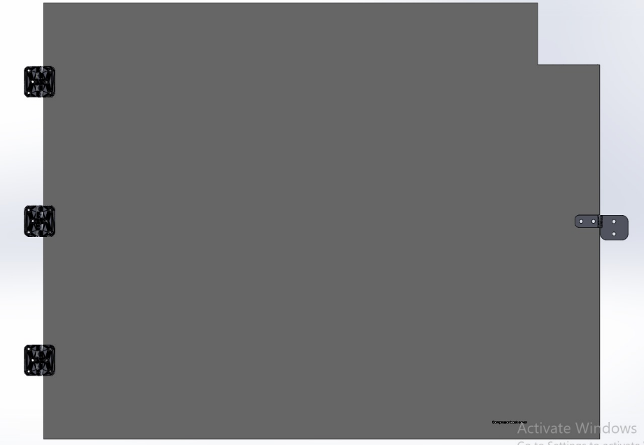
Figure 4.5.2 Back door of compressor and hydraulics pump closure design
The rear panel is hinged to the frame using 3D-printed hinges (Figure 4.5.3). It features a padlock-ready latch and a cable access slot in the upper-right corner.
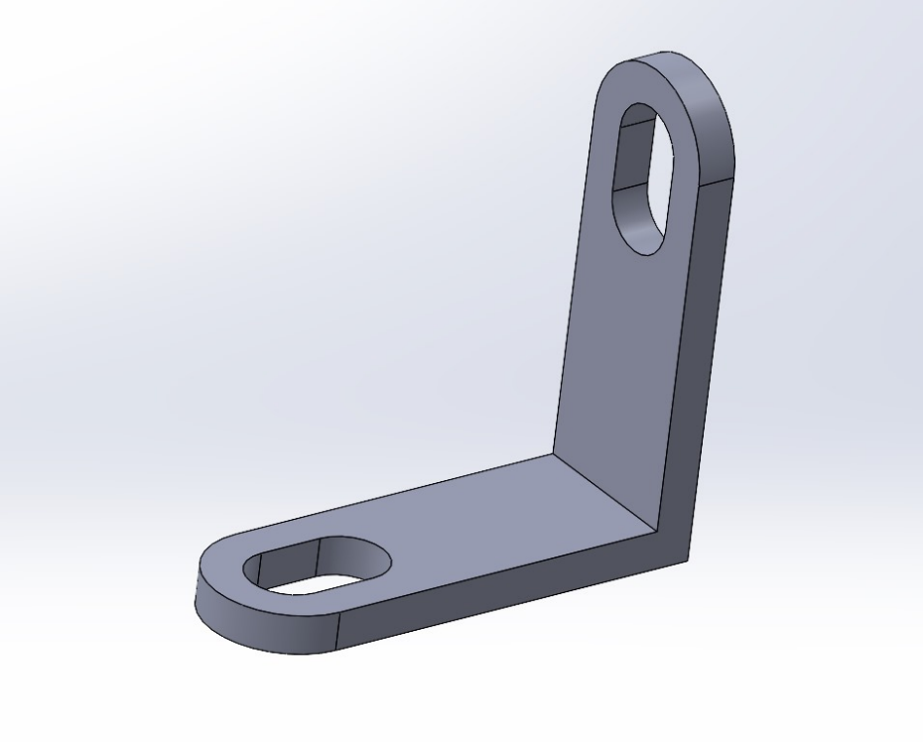
Figure 4.5.3 Adapter for a bottom part of compressor and hydraulic pump cover
Due to installation constraints for the bottom panel, a custom adapter is proposed to connect it securely to the side panel. Assembly manual is available under Appendix B.

Rewiring, Cable Management and Total Maintenance
Goal: To eliminate unsafe or unused wiring, improve visual clarity, reduce short-circuit risk, and prepare the system for stable long-term use.
Related Risks: ID 15 (short circuit due to wiring), ID 11 (loose components), ID 2 (touching open terminals)
A critical aspect of the system’s safety and reliability is the organization and protection of electrical wiring. In its current state, the Mini Factory features excessive, unorganized wiring, including unused or outdated electrical components that pose risks of short-circuiting, entanglement, and unintended operation. Given that the system has not been in use for a prolonged period, a comprehensive maintenance and cleanup process is essential. This includes removal of dust, inspection of lubrication points, and replacement of oxidized connectors or degraded insulation.
To address these issues and align with the visual and safety goals of the exhibit, the following design and organizational upgrades are proposed for the electrical section: A centralized aluminum mounting plate will serve as the base for all functional electronics. This enables modular layout, clear component mapping, and simplified diagnostics while still allows children to see all the components of the system.
Implementation Considerations:
While a full electrical rewiring and layout overhaul is the ideal scenario, the current human resource constraints may limit this intervention in the short term. As a result:
- Basic cable management must be prioritized, including bundling, labeling, and rerouting of wires using standard channels and ties.
- All unused components should be identified and permanently disconnected or removed to eliminate ambiguity and reduce risk.
- Visual indicators (e.g., LED status displays) and clearly labeled terminal blocks are recommended for quick fault identification.
These upgrades not only enhance the safety and maintainability of the electrical system but also directly support the user experience, allowing students and museum visitors to visually understand the “brain” of the Mini Factory without compromising operational security. Figure 4.6.1 show results of the work done.
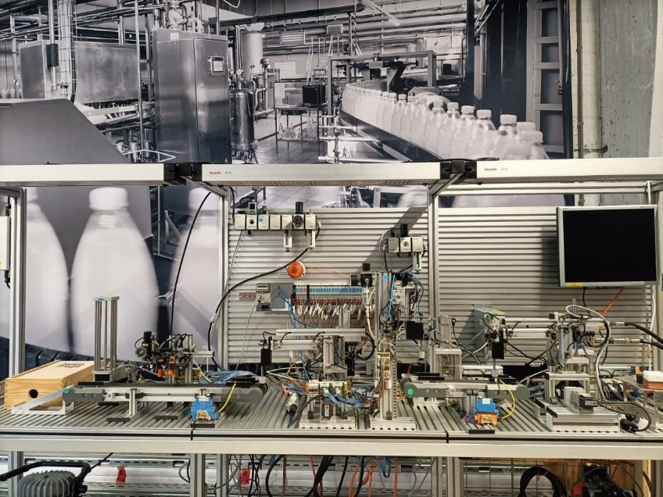
Figure 4.6.1 Results of set-up cleaning up

Electrical System Safety Integration
Goal: To ensure system-wide electrical safety through improved documentation, zoning, and preparation for new I/O integration.
Related Risks: ID 15 (short circuit), ID 5 (E-stop system fails), ID 3 (ungrounded frame)
To ensure safe operation, reliable performance, and compliance with international standards such as ISO 13849, IEC 60204-1, and ISO 14119, the electrical system of the Mini Factory is undergoing a comprehensive upgrade. This effort is especially important as the current installation lacks proper documentation, including an official electrical schematic, and features outdated, loosely integrated wiring with no functional zoning. Furthermore, a new I/O system is pending delivery, and therefore some electrical layout decisions will be finalized later in the project.
To address these shortcomings, a new electrical schematic will be developed by a collaborating MBO student from Koning Willem College as part of the rewiring phase. This will ensure all modifications are properly documented, including wiring diagrams, fuse sizing, and relay control logic. All components used will be logged and visualized for future maintenance and handover to Actemium.

4.7.1 Current vs. Target Electrical Configuration

Table 4.7.1.1 explain overall target for electrical safety implementation. Figure 4.7.1.1 show the overall electrical overview of the system and Figure 4.7.1.2 shows final target for electrical enhancements.
Table 4.7.1.1 Target electrical implementation vs. current system
Aspect | Current System | Target System (Post-Upgrade)
Power Line | Centralized 230V AC | Distributed through MCBs and contactors
Safety Zoning | Not implemented | 3 electrical safety zones (aligned with mechanical zones)
Emergency Shutdown | Basic main switch | Individual zone-based E-Stop logic via safety relays
Fault Isolation | Minimal | RCDs, grounding, and selective MCBs
Documentation | Missing | Schematic in development (MBO student task)
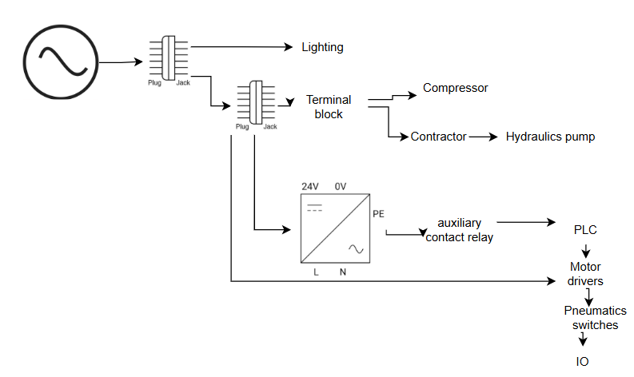
Figure 4.7.1.1 Current electrical connections overview
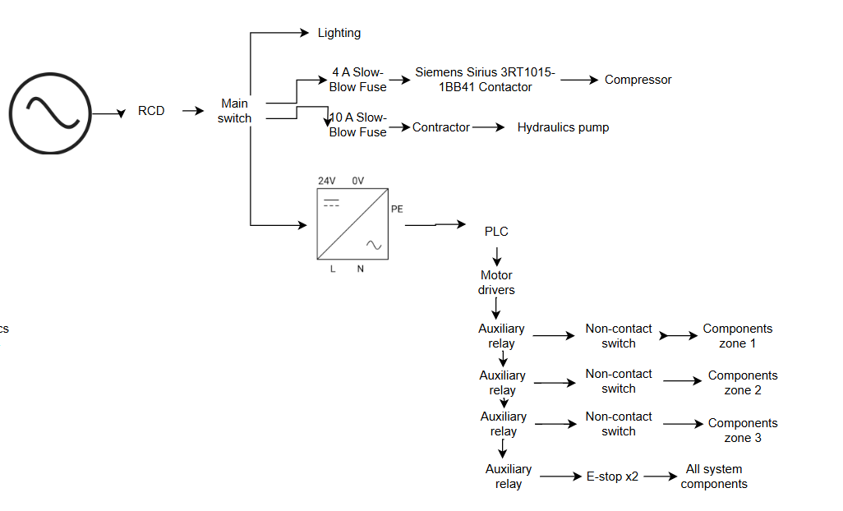
Figure 4.7.1.2 Safety enchased electrical design

Documentation of selected components and design references is available in the project’s GitHub repository (Appendix B).

4.7.2 Residual Current Device (RCD) & Main Switch Integration
Goal: To detect and interrupt fault currents and isolate the system for safe shutdowns and maintenance.
Related Risks: ID 3 (ungrounded frame), ID 2 (touching open terminals)
RCD Functionality: Detects leakage current (e.g. >30 mA) and disconnects power within milliseconds to prevent electric shock. Combined with proper grounding, it prevents metal components from becoming live in case of insulation failure.
Main Switch Purpose: Allows full isolation of the system for maintenance, emergency intervention, or reconfiguration.
Components Considered:
- RCDs: ABB F202 A-40/0.03, Hager CDA240D, Schneider A9R11240
- Main Switches: ABB OT40F3, Schneider VCF1, Schneider Vario
- Grounding: Phoenix UK 6 PE terminal blocks, 2.5–4 mm² wire, earth busbar
Recommended Setup:
- RCD: ABB F202 A-40/0.03, Type A, 2P, 40A, 30mA
- Main switch: Lockable 3P 40A switch, located near operator access point
- All metal parts must be grounded using star washers and PE links

4.7.3 Compressor – Electrical Protection
Goal: To ensure proper circuit protection of the compressor to prevent electrical failure and overheating.
Related Risks: ID 15 (short circuit), ID 3 (ungrounded frame)
The Jun-Air 6-S compressor, rated at 230V, draws approximately 4 A and generates inrush currents on startup. Without proper protection, this may lead to circuit tripping or fire hazards.
Options Considered:
- Industrial fuses (gG 6.3 A): Low cost, but lacks thermal overload protection
- MCB + Thermal Relay: More robust, simplifies diagnostics and manual reset
Recommended Setup:
- Contactor: Siemens Sirius 3RT1015-1BB41 (9 A, 230V coil)
- Protection: 6 A C-curve MCB or slow-blow fuse
- Grounding: All metallic components must be earthed via PE terminal blocks
Important: If the MCB design is chosen then MCB needs to be wired according to the Figure 4.7.3.1. It is since normally MCBs are designed for 400V AC, but this system components are powered with 230V AC.
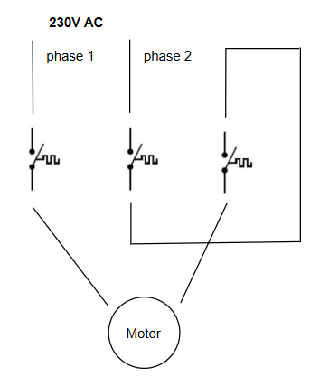
Figure 4.7.3.1 MCB wiring diagram

4.7.4 Hydraulic Pump – Electrical Protection
Goal: To protect the 400V pump system from overloads and short circuits while ensuring user safety.
Related Risks: ID 15 (short circuit), ID 3 (ungrounded frame)
The hydraulic pump operates at 400V, 4–6 A. It requires isolation and protection against overloads, especially because of its mechanical power and proximity to children.
Options Considered:
- Tripus 0629-3 switch + 10 A gG fuse: Economical, includes thermal trip
- MPCB (e.g. Eaton PKZM0-6.3): Easier PLC integration and precise reset handling
Recommended Setup:
- Contactor: Eaton DIL R40 (already installed)
- Protection: 10 A Type C MCB or 10 A slow-blow fuse
- Optional: Thermal relay ZB12-6.3 (if MPCB not installed)
Important: if MCB is used, then refer to the Figure 4.7.3.1 for electrical wiring diagram

4.7.5 Emergency Stop & Zone Interlock Safety Integration
Goal: To implement a dual-layer safety system combining local interlocked access prevention with global emergency shutdown, ensuring safe interaction for children in a public museum environment.
Related Risks:
- ID 5 (E-stop fails)
- ID 1 (pinching)
- ID 8 (overextension)
- ID 12 (object intrusion into moving parts)
To comply with ISO 13849 and support safe, zone-based operation, the MiniFactory is divided into three independent electrical safety zones. Each zone includes:
- A non-contact safety switch (interlocked door) to prevent access during operation
- A dedicated safety relay to isolate motion and pneumatics locally if that door is opened
In addition, a global Emergency Stop system is implemented using:
- Two E-stop buttons, placed at opposite ends of the exhibit
- One shared safety relay, cutting power to all zones in critical situations
Table 4.6.5.1 show complete overview of safety zoning.
Table 4.7.5.1 Updated Safety Zoning & Logic
Zone | Controlled Devices | Interlock Safety Switch | Local Relay | Global E-Stop Coverage
Zone 1 | Pneumatics, motors | Schmersal AZM40 or equiv. | Yes | Yes
Zone 2 | Same | Schmersal AZM40 or equiv. | Yes | Yes
Zone 3 | Same | Schmersal AZM40 or equiv. | Yes | Yes
Exhibit Ends | — | — | Main system relay | E-Stop buttons ×2
Components Selected:
- E-Stop Buttons: Red mushroom-type, Normally Closed (NC), located at each end of the exhibit
- 🔒 Non-contact Safety Switches: Schmersal AZM40 (coded actuator, IP67, PL e compliant)
- ⚡ Safety Relays:
  - 3 × Pilz PNOZ X2.1 (one per zone)
  - 1 × Pilz PNOZ X3 or ctrlX SAFEX for global E-stop chain
- 🔌 Contactors: Finder 38.51 (24VDC coil) or equivalent for actuator isolation
- 💡 Logic Flow:
  - Zone Interlocks → Local relay disables motion in that zone
  - E-stop Buttons → Global relay disables all relays and actuators
  - PLC remains powered during E-stop for diagnostics and logging
This dual-safety scheme ensures that:
- Each zone can be entered safely after local power-down via interlock
- Emergency stops instantly cut all power across zones, without delay
- Children and museum staff can act quickly and safely in any situation

4.7.6 Covers for Reachable Electronic Components
Goal: To enclose exposed or accessible electronics (buttons, sensors) to prevent accidental contact or tampering by users.
Related Risks: ID 2 (touching terminals), ID 12 (object intrusion), ID 6 (joystick/button jam)
To complete the system’s protective structure, all exposed buttons, sensors, and terminals will be housed in custom 3D-printed covers. These will prevent accidental access while preserving visibility.
Cover Types to be Fabricated:
- 2 × Button covers
- 2 × Sensor covers
- 1 × Test stand cover
- 2 × Motor covers
- 2 × Press electronics covers
These covers are lightweight, removable, and cost-effective. All design files and STL models are available in the project GitHub repository (Appendix B).

Software-Based Motion Limits
Goal: To prevent overextension of moving actuators by enforcing safe boundaries through software logic.
Related Risks: ID 8 (overextension), ID 9 (software crash)
To prevent mechanical overtravel and reduce the risk of user injury or equipment damage, software-enforced motion limits have been implemented for all actuated components, particularly the two main manipulators and the press system.
Each actuator is assigned a predefined operational boundary based on the physical limits identified during risk assessment and mechanical integration. These constraints are continuously monitored during runtime through encoder feedback or control logic bounds. If a motion command attempts to exceed these predefined thresholds, the system:
- Interrupts the operation immediately
- Triggers an emergency stop state
- Prevents any further commands until the component is reset within a safe range
This strategy not only satisfies core system safety requirements (SSR.6, TSR.1) but also offers a programmable safeguard that complements physical barriers and interlocks.
Software-based limits are especially useful in educational environments where inexperienced users may unknowingly input unsafe commands. Unlike hard end-stops, software limits are easily configurable and scalable as the system evolves, making them an essential part of both prototyping and future-proofing the installation.
Additional software safety mechanisms—such as user access levels, interface flow, and instructional overlays—are discussed in Chapter 6: Software Design. Precise information on software limits will be available after rewiring of existing system.

Full Component & Manufacturing Table
To implement the safety redesign of the Bosch Rexroth Mini Factory, a detailed budget estimate is required. This budget includes costs associated with mechanical redesigns, electrical upgrades, safety components, software modifications. Table 5.1 and Table 5.2 list all the proposed components in this design brief. Components listed in black are mandatory ones, while components in blue are optional but still recommended.

Table 5.1 Components list with recommended suppliers for safety implementation
Component | Purpose | Qty | Approx. Price (each) | Supplier
ABB F202 A-40/0.03 RCD | Residual current protection | 1 | €110.85 | Elettronew
ABB OT40F3 Main Switch (Lockable) | Main system isolation | 1 | €41.60 | Farnell
Contactor for Compressor (Siemens Sirius 3RT1015-1BB41) | Start/stop compressor | 1 | €35–50 | Conrad / Farnell
MCB 6A Type C for Compressor | Overcurrent protection | 1 | €7–10 | Schneider / ABB / Hager
MCB 10A Type C for Hydraulic Pump | Overcurrent protection | 1 | €7–10 | Schneider / ABB
Thermal Overload Relay | Motor protection if no MPCB | 1 | €30–45 | Eaton (ZB12-6.3)
Emergency Stop Buttons (NC) | Safety shutdown | 3 | €5–15 each | Schneider, IDEC, EAO
Safety Relay (Pilz PNOZ X2.1 or ctrlX SAFEX) | Process monitoring and E-stop logic | 4 | €120–300 each | Pilz / Bosch Rexroth
3D Printed Safety Covers (PLA) | Custom machine safety parts | ~10-15 items | €18.99/kg (PLA) | Filamentz.nl / Reprapworld
2mm Polycarbonate Sheet (1x1 m) | Interlocked safety windows | 5 | €32.40 each | Kunststof Forte BV
2mm Acrylic Sheet (1x1 m) | Covers and decorative parts | 2 | €16.02 each | SIA Ultraplast EU
Schmersal AZM40 | Interlocked doors safety | 3 | €45-60 | Schmersal
IDEM PRH-12-SS | Interlocked doors safety (either this component or previous one) | 3 | €75-90
Curtain railing | Railing for interlocked doors | 6 | €62,80 | AliExpress
Moerhammers and M6 screws | Assembly |  | €100
Total |  |  | €1312-2091

Table 5.2 Manufacturing list with recommended suppliers

Material / Workpiece | Purpose | Qty | Process Required | Notes
2mm Polycarbonate Sheets | Safety doors, windows | 5 x 1×1 m | Laser cutting + heat bending | Use for moving parts, doors
Laser-Cut Acrylic Sheets | Panels, mounting plates | 12 (custom designs) | Laser cutting | Exact dimensions needed
2mm Acrylic Sheets | Side covers | 2 x 1×1 m | Laser cutting | Transparent or opaque
Colored Acrylic Sheets | Branding or visual safety areas | 2 x 1×1 m | Laser cutting | e.g. red, yellow, blue

Maintenance Plan
To ensure the safe, reliable, and long-term operation of the Mini Factory installation—especially in a public, high-usage educational setting—a structured and preventive maintenance plan is critical. This plan minimizes downtime, prevents safety degradation, and extends the system's operational life, particularly in light of its exposure to repeated interaction by children and the sensitive nature of its pneumatic, hydraulic, and electronic components.
Regular maintenance is not only a best practice but also a compliance requirement under standards such as ISO 12100, ISO 13849, and IEC 60204-1, which mandate that safety-related parts of control systems are inspected, tested, and validated over time.
How the Maintenance Schedule Was Developed
The maintenance schedule was developed by analyzing a combination of manufacturer datasheets, risk assessment outcomes, and relevant international safety standards, particularly:
- ISO 12100: General principles for risk reduction
- ISO 13849-1: Safety-related parts of control systems
- IEC 60204-1: Electrical equipment of machines
Manufacturer guidelines for components such as the Jun-Air compressor, Bosch Rexroth pneumatics, and Eaton hydraulic pumps.
- To ensure that the safety and reliability of the Mini Factory are maintained throughout its public use lifecycle, each system component was cross-referenced against:
- Operating environment and exposure (e.g., frequent interaction by children, indoor humidity, long idle periods)
- Expected mechanical wear or failure mode (e.g., oil degradation, tubing leaks, cable stress)
- Recommended maintenance intervals from datasheets
- Design decisions specific to this project (e.g., 3D printed parts that are less durable than metal alternatives)
For instance:
- The compressor datasheet recommends draining moisture weekly and replacing filters bi-annually under moderate duty cycles.
- The pneumatics system includes cylinders and valves whose seals may degrade over time or leak without lubrication—hence the bi-weekly inspection cycle.
- Hydraulic systems require periodic oil checks and annual replacement, as per industrial standard practice (often listed in technical manuals).
- Safety devices like E-Stops and interlocks, classified under Category 3 or 4 per ISO 13849, must be validated frequently, especially when operated in an uncontrolled public setting.
- PLC modules and interface screens, while electronically reliable, are prone to wiring fatigue and physical wear over time, particularly when unshielded or mounted in movable exhibits.
The final plan was then adapted to the project context: limited technical staff, museum operating hours, and mixed-use educational objectives. As such, the plan balances preventive maintenance with ease of scheduling and task distribution, making it feasible for both professional technicians and trained museum staff to contribute to the system's longevity and safe use. Table 6.1 explains parties involved in the maintenance and Table 6.2 describes maintenance schedule

Table 6.1 Roles and Responsibilities
Role | Responsibility
Maintenance Technician | Performs inspections, lubrication, basic repairs
Safety Officer | Verifies safety device functionality and logs inspections
Electronics/PLC Technician | Manages control system integrity, backups
IT Staff | Ensures UI/UX devices are functional and up-to-date
Museum Host / Staff | Performs daily checks and surface cleaning
Supervisor / Project Lead | Reviews logs, validates updates, oversees audit readiness

Table 6.2 Maintenance plan overview
Component / System | Inspection Frequency | Maintenance Task | Responsible Person / Role | Notes
PLC & I/O Modules | Monthly | Check wiring integrity, module status LEDs, ensure communication | Technical staff / Electronics Tech | Backup PLC program should be checked annually
Compressor Unit | Weekly (visual) / Monthly (functional) | Inspect air leaks, pressure, temperature; drain tank | Maintenance Technician | Replace air filter every 6 months
Pneumatic System | Bi-weekly | Check tubing for leaks, inspect cylinders and valves | Maintenance Technician | Lubricate every 6 months
Hydraulic Pump & Press | Weekly (visual) / Monthly (functional) | Check fluid levels, inspect press movement and safety covers | Certified Technician | Change oil annually; check pressure quarterly
Safety Devices | Weekly | Test E-stops and interlocks; check wiring | Safety Officer / Technician | Record tests; replace faulty devices immediately
Transparent Covers / Screens | Monthly | Clean and inspect for damage | Maintenance Team | Replace damaged screens immediately
Structural Frame | Monthly | Check for loose bolts, wear, alignment | Maintenance Team | Tighten connections; check for deformation
Wiring & Cable Management | Monthly | Inspect wires/connectors; ensure proper routing | Electrical Technician | Replace any damaged cables
User Interface Screens | Weekly | Check responsiveness and wear | IT / Maintenance Team | Replace scratched/damaged screens
3D Printed Covers & Mounts | Quarterly | Inspect for cracks/deformations | Maintenance Team | Reprint and replace as needed
General Cleaning | Weekly | Wipe exposed surfaces and user areas | Museum staff / Host | Prevents dust accumulation and wear

Appendix C has maintenance forms and report`s frameworks.

Testing and Validation Plan
While this internship concludes with the design, development, and pre-assembly of the updated Bosch Rexroth Mini Factory, the final physical integration and operational deployment will be executed after the current project timeline. Therefore, this chapter proposes a testing and evaluation framework (Table 7.1) to be implemented once the full system is manufactured, assembled, and installed at The Chocolate Factory.
Objectives:
- Validate that all hazardous zones are physically and/or electronically protected.
- Confirm proper operation of all emergency stop systems, interlock mechanisms, software safeguards, and electrical isolators.
- Ensure compliance with ISO 12100, ISO 13849-1, ISO 14119, and IEC 60204-1 standards.
Table 7.1 Safety Validation Steps
Test ID | Validation Item | Method | Standard Reference | Success Criteria
SV-01 | Mechanical Guarding (Zoning & Screens) | Measure screen thickness, mounting integrity, safety distance | ISO 13857, ISO 12100 | All screens ≥6 mm, no access within 50 mm of hazards
SV-02 | Interlocked Door Testing | Verify interlock prevents opening during active operation | ISO 14119, ISO 13849-1 | Door locked until system stops; door opening halts motion
SV-03 | Emergency Stop Functionality | Activate E-Stop in all zones during operation | IEC 60204-1 | System stops within 300 ms; resume only via reset
SV-04 | Electrical Isolation | Test RCD trip current and grounding integrity | IEC 60204-1 | RCD trips at 30 mA, all exposed metal grounded
SV-05 | Software Motion Limits | Simulate actuator exceeding limit | Internal logic (SSR.6) | Motor stops; emergency flag raised in GUI
SV-06 | Non-reversible Access Check | Attempt access to live terminals/components | ESR.1 | No user-accessible live parts without tools
SV-07 | Maintenance Zone Access | Validate rear compressor and electrical panels only accessible via secured covers | ESR.3, MSR.6 | Rear doors padlocked; screw-fixed or hinged only
Documentation: All validation outcomes must be recorded in the Safety Compliance Report, signed by the supervising engineer and reviewed by a certified safety specialist. Deviations require immediate mitigation or written justification approved by The Chocolate Factory's facilities supervisor.

Conclusions and recommendations
The Bosch Rexroth Mini Factory transformation into an educational installation presents a unique challenge: maintaining safety within a highly interactive, child-friendly environment. Through this risk assessment, multiple critical hazard domains were identified and thoroughly evaluated, resulting in a robust mitigation strategy.
The combination of physical barriers, safety zones, electrical system overhauls, and user behaviour control mechanisms creates a safe and engaging exhibit space. The modular and well-labelled design facilitates not only ease of maintenance but also enhances educational transparency for students and facilitators alike.
Ultimately, the redesign meets the intended use case while adhering to industry-standard safety requirements, ensuring it can be safely operated by and around children.

Recommendations
- Safety Validation: All safety mechanisms—especially door interlocks, emergency stops, and grounding—must be validated during commissioning and reviewed every 6 months.
- Phased Upgrades: For long-term scalability, consider future upgrades including area scanners and light curtains for advanced safety monitoring.
- Educational Materials: Develop a safety training module for museum staff and visual guides for visitors that integrate into the exhibit itself.
- Budget Flexibility: Allocate contingency budget for unexpected hardware adjustments, especially in custom mechanical safety features.
- Documentation Access: Maintain an open-access GitHub repository with mechanical drawings, wiring diagrams, and training materials to support transparency and troubleshooting.

Appendix A: project`s GitHub
GitHub: https://github.com/anastasiia-gif/MiniFactoryTCF.git

Appendix B: proposed components
Curtain railing: https://nl.aliexpress.com/item/1005008255834174.html?src=google&pdp_npi=4%40dis!EUR!72.49!67.69!!!!!%40!12000044392455316!ppc!!!&src=google&albch=shopping&acnt=272-267-0231&isdl=y&slnk=&plac=&mtctp=&albbt=Google_7_shopping&aff_platform=google&aff_short_key=UneMJZVf&gclsrc=aw.ds&&albagn=888888&&ds_e_adid=&ds_e_matchtype=&ds_e_device=c&ds_e_network=x&ds_e_product_group_id=&ds_e_product_id=nl1005008255834174&ds_e_product_merchant_id=106260155&ds_e_product_country=NL&ds_e_product_language=nl&ds_e_product_channel=online&ds_e_product_store_id=&ds_url_v=2&albcp=20730513328&albag=&isSmbAutoCall=false&needSmbHouyi=false&gad_source=1&gad_campaignid=20726902985&gbraid=0AAAAAoukdWPstYXC3VFxAA5a4sxHz5UL8&gclid=CjwKCAjw_pDBBhBMEiwAmY02NvjIOIGOHaNm5tlF3lHZDlTxX-s95i9BtpEkPCQkrBSn6ZB3TO7jWRoCCjgQAvD_BwE#nav-description

Appendix C: Maintenance Forms and reports
To ensure the Mini Factory remains safe, functional, and engaging for all users—particularly children—a structured maintenance documentation system has been developed. This appendix contains the standardized forms and reporting templates used to track, evaluate, and optimize the system’s upkeep throughout its lifecycle.
The documentation serves multiple purposes:
- To verify compliance with ISO 12100, ISO 13849, and preventive maintenance principles as per IEC 60204-1.
- To provide traceability and accountability for all maintenance activities.
- To assist future operators and technicians in detecting trends, addressing emerging faults, and planning upgrades.
The following tools are included:
- Annual Maintenance Summary Report
A comprehensive yearly overview of system reliability, maintenance events, critical failures, recurring risks, and budgetary considerations. This summary helps supervisors and stakeholders make informed decisions about system improvements or part replacements.
- Maintenance Checks Form
A checklist-format sheet used during periodic inspections to record the condition of each key system component, from PLCs and pneumatic tubing to safety devices and 3D printed covers. Each entry includes task frequency and responsible personnel.
- Maintenance Log
A technician-level logbook for tracking individual maintenance events. This allows precise documentation of task execution, observed issues, resolution steps, and personnel involvement. The log is essential for ensuring continuity and transparency across shifts or teams.
These documents are intended to be used iteratively throughout the year, forming the basis for validation, audit-readiness, and future training initiatives. Blank versions are provided and can be printed or digitized as needed.
Annual Maintenance Summary Report

1. System Overview
System Name: Bosch Rexroth Mini Factory
Location: [Insert location]
Year: 2025
Responsible Supervisor: [Insert Name]
2. Summary of Performed Maintenance
Total routine inspections completed: ___
Number of component replacements: ___
Total downtime due to maintenance: ___ hours
Emergency maintenance cases: ___

3. Notable Incidents or Repairs
Date | Issue Reported | Component | Resolution Action | Downtime (hrs) | Remarks

4. Trends & Risk Observations
- Recurring issues: (e.g., frequent air leaks in pneumatic tubing)
- Components showing early wear: (e.g., joystick buttons degrading quickly)
- Safety system performance: (e.g., 100% E-stop functionality verified monthly)

5. Recommendations
- Replace [Component X] in Q3 due to wear.
- Budget required for spare parts: €___
- Suggested upgrades: [e.g., light curtain integration, improved joystick material]

6. Training & Documentation
- Number of staff trained on safety procedures: ___
- Documentation updates made: [List documents updated or added]
Maintenance checks form
Component/System | Task Description | Frequency | Responsible Role | Checked (✔/✘)
PLC & I/O Modules | Inspect wiring, check LEDs, test communication | Monthly | Electronics Technician
 | Backup PLC program | Annually | Electronics Technician
Compressor Unit | Check for leaks, pressure, temperature | Weekly (Visual) | Maintenance Technician
 | Drain moisture from tank | Monthly | Maintenance Technician
 | Replace air filter | Every 6 months | Maintenance Technician
Pneumatic System | Check tubing, cylinder/valve response | Bi-weekly | Maintenance Technician
 | Lubricate moving parts | Every 6 months | Maintenance Technician
Hydraulic Pump & Press | Check fluid levels, leaks, press movement | Monthly | Certified Technician
 | Change hydraulic oil | Annually | Certified Technician
 | Check pressure settings | Quarterly | Certified Technician
Safety Devices (E-Stops etc.) | Test response, check wiring and contacts | Weekly | Safety Officer / Technician
Transparent Covers & Screens | Clean, inspect for cracks or warping | Monthly | Maintenance Team
Structural Frame & Table | Tighten bolts, check for wear and instability | Monthly | Maintenance Team
Wiring & Cable Management | Inspect for damage, loose connectors | Monthly | Electrical Technician
User Interface / Buttons | Test responsiveness, look for damage | Weekly | IT / Maintenance Team
3D Printed Parts & Covers | Check for cracks, deformation | Quarterly | Maintenance Team
General Cleaning | Wipe surfaces, user touchpoints | Weekly | Museum Staff / Hosts
Maintenance log
Date | Component/Area | Task performed | Issue | Action taken | Technician name | Sign

Document Revision The following revision numbering is applied to this document: Revision (or Rev.): GGRR For new project documents, the revision number is 0000. Revisions for approval, the revision number is GGRR in which GG = 00 to 99 and RR = 01 to 99. Approved revisions, the revision number is GG00 in which GG = 01 to 99.

